**Wrong Ref: Load Number Removing Tool (Shipment)**

**Description:**

This tool removes the wrong Ref: Load Number that attaches to a shipment. Whenever an order gets re-planned, the historical load will be removed while a new load is attached. However, the reference remains on the shipment. The program automatically identifies attached load number, compares it with Ref: Load Number, and then, remove the wrong ones.

**Standard Operating Procedure:**

1. Download the zip file from below link:

<https://drive.google.com/a/dsclogistics.com/file/d/1Kmz4OxLNgJIp94AfuaWozr04viVkPkpf/view?usp=sharing>

1. Save the zip file in a preferred folder, extract it by right-clicking and selecting ‘Extract All..’.

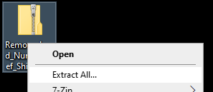

1. Click ‘Extract’ without changing anything.

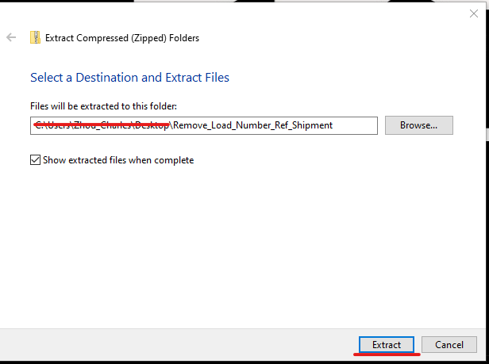

1. Open the folder extracted, there are 5 files.

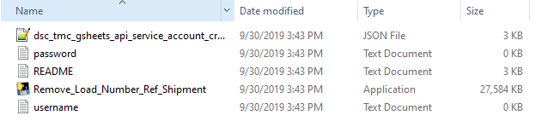

1. Open username.txt and password.txt using Notepad, save your TMS username and password to each file respectively (DO NOT include any space).
2. Login to TMS ezVision, go to legacy view -> Shipments -> 80 – Ref Load Number Removal.

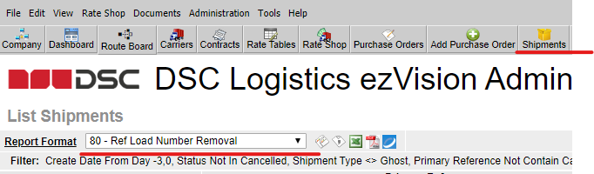

1. Download the report by clicking the little Excel button.
2. Convert the download from .xls to .xlsx format by opening it. Go to File -> Info -> Convert.

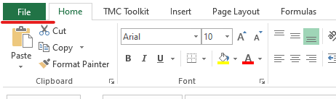

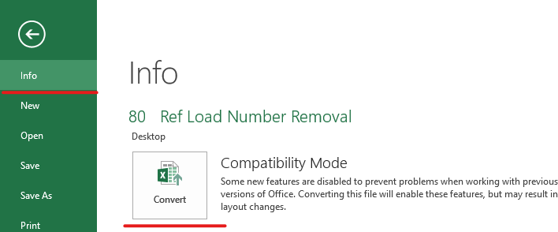

1. After conversion, close the Excel, rename the file as ‘Dynamic’.

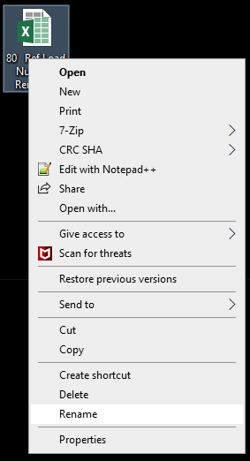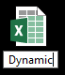

1. Copy the file to the folder extracted above. Overwrite the historical file if there is one. DO NOT let the system automatically rename it as ‘Dynamic (1)’ or anything similar, the program DOES NOT recognize any file name other than ‘Dynamic’.

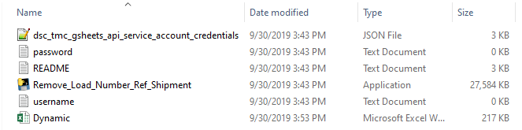

1. Double-click ‘Remove_Load_Number_Ref_Shipment’ to launch the program. It runs automatically. If it closes itself within 10 seconds, it means there is bug, and it runs unsuccessfully. Please report the issue.
2. If the program run successfully, it will show a screen like below:

